**ENGR 4020 Milestone 3[1] [100 pts]**

**Demonstrate by 3/5/2020, 5PM**

**Milestone Report by 3/6/2020, 4PM**

**Demonstration after the Due Date: [60 pts]**

In this milestone, you must demonstrate navigation of the playfield with your robot, and the ability to collect and return an object to base.

**Tasks**

Your robot must start completely within the 12”x12”x12” starting cube. The robot must acquire a cube from either location and deliver it to the base on the opposite side of the playfield. The robot does not need to recognize the color of the cube, nor sense that the cube has been acquired.

You have exactly three ‘official trials’ before the due date to demonstrate operation to Dr. McPheron. The first two official trials are taken with no penalty but requiring a third official trial will be a deduction of 10 points. You have unlimited official trials after the due date, but the penalty is a deduction of 40 points.

**Requirements**

1. Demonstrate the tasks outlined above. Demonstration after the due date will yield a deduction of 40 points from the total score.
2. Submit a milestone report. The milestone report must summarize the approach to the milestone as well as the performance and reliability in meeting the milestone. You must also submit a flowchart for the program’s actual structure, a copy of the .cpp file (with comments) and a diagram of the circuit used. This submission is on paper! This report must be put in your group’s design notebook, and the whole notebook turned in to Dr. McPheron.
3. Included in the Milestone Report, you must also have a 3D model of your robot, pictures of your robot demonstrating that the two match, and an AutoCAD drawing demonstrating the group is following the material restriction requirements, as shown in the example below.

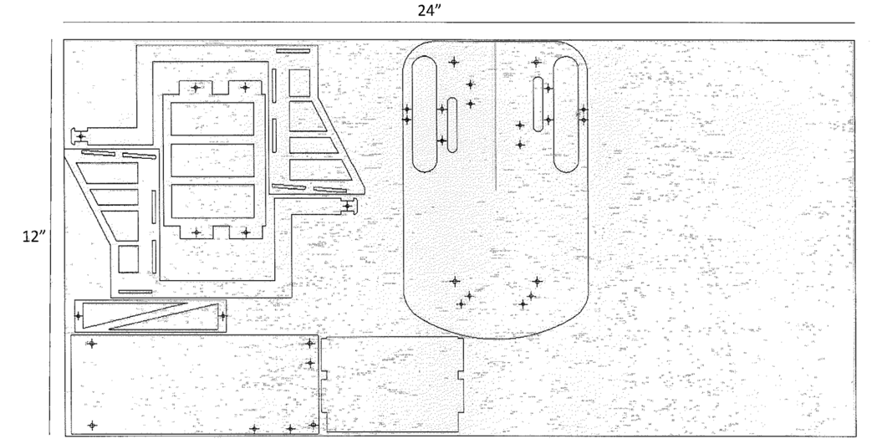

1. Adapted from ENGR 450: Mechatronics by Matthew Stein, Roger Williams University